# 13. Revision Lab

**Tasks**

Download the starting files from Moodle for this lab.

In this zipped file you will find the HTML and CSS code. I have also created the JavaScript file, but you will need to write the code for the functionality described below.

**Ensure that you have the console open** when you are testing your code. This way if an error occurs, the console will help/show you.

**Documentation**

This is your starting point to get support for JavaScript Objects

<https://developer.mozilla.org/en-US/docs/Web/JavaScript/Reference/Global_Objects>

**Getting prepared**

1. To help you get ready for CA2, you need to revise all the JavaScript material we have done to date. However, I have listed some of the main tasks below, which you should review by going through the previous labs.
2. After the main tasks listed below, I have a lab exercise where you can practice several of these tasks.
3. Finally, I have listed some cheat sheets for quick access to specific JavaScript code.

**Main tasks to be able to do in JavaScript**

1. Variables – var, let const
2. String Properties & Methods <https://www.w3schools.com/jsref/jsref_obj_string.asp>
3. IF statements
4. Events – onclick(), onchange(), onload(), onmouseover() etc
5. Loops – for, while & do while
6. Functions - parameters from the Html page
7. Arrays - create, add & access values. Loop to iterate through the array.
8. Objects - create, add, and access values.
9. DOM - enable and disable buttons

- access and set values in the Html page

* document.getElementById() &
* document.getElementsByClassName ()
* Element. setAttribute()
* innerHTML

**Tasks to do in the lab.**

When you open the starting **index.html** (in the downloaded start files) page in the browser you will see the following:

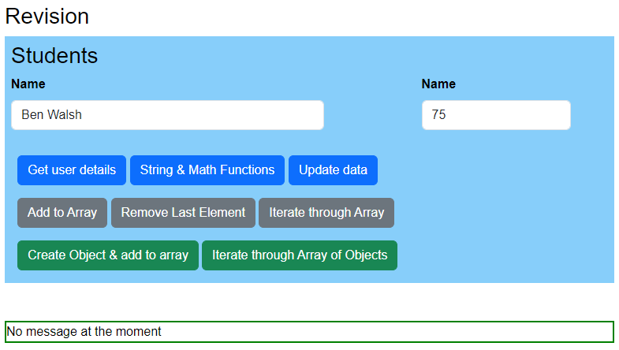

Now, using the downloaded files, **add the function calls** to the Html page **and write the JavaScript code for each button,** to complete the following tasks.

1. **Get user details.**

* Get the **Name** and **Result** from the text boxes.
* Output these values to the console.
* If the user’s result is 70 or above, then output a message to the console.
* If the user’s result is below 70, then output a different message to the console.
* Then using the innerHtml property, update the page like below (after the form).

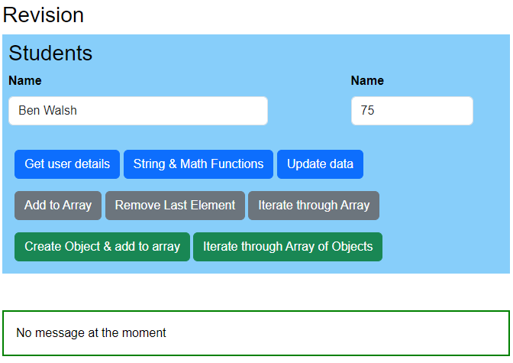

1. **Click on a Div.**

Not only can you click on buttons but also click on DIVs, Images, etc.   
Add an **onclick** call to the **message div**.

<div id="message" onclick="divFunction();">

Then write the JavaScript function, divFunction(). This function:

* shows an alert message
* sets the padding to 4rem.
* changes the border to 2px red.

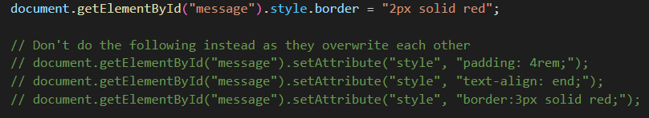

1. **String and Math functions**

There are many String, Math, and other JavaScript functions you can use. See the list of String functions above and below in the cheat sheet.  
This function will get the **Name** from the text box and then write to the console:

* Uppercase version of this name
* Lowercase version of this name
* Characters from 2 to 7 in the name – use the function **slice**
* Get a random number between 1 and 10. Use this function below. Make sure you know how it works. For example, what does **+ 1** do?

let randonNumber = Math.floor(Math.random() * 10 ) + 1;

1. **Update data**

Update the values in the text boxes with any other values. For example:

document.getElementById("fullName").value = "Jamie";

document.getElementById("result").value =  "90";

We would never hard-code values (Jamie and 90) like this, but this shows you how to update the text box. Typically, we might update a text box with user input or a calculation value.

The user can click this button once. So, if they click this button again, give them a message saying they have clicked this button already.   
You will need a variable to keep track of the user clicking this button. Then you will need to write an IF statement to determine if you need to show them the message. Finally, disable the button in this IF statement.

**Arrays**

1. **Add to Array**

Create a **global** array called **names**. Add the value in the **Name** text boxto the array. Each time the user clicks this button, add the value in the **Name** text boxto the array.

Write to the console, the Name added to the array and the array length.

1. **Remove the Last Element in the Array**

Remove the last element from the array.

Write to the console, the Name removed from the array and the array length.

1. **Iterate/Loop through Array**

Iterate through the array, printing all values to the console. It is useful to print the length of the array at the start too.

**Objects**

**Note -** I am using a different array (**users**) to avoid confusion with the previous examples.

1. **Create an object and add it to this Users** **Array**

Create an object called **user**. This will be a local variable (a variable declared in the function) and not a global variable. Add the **Name** and **Result** text box values to the **user** object.

Then add this object to the **users** array.

1. **Iterate/Loop through an Array of Objects**

Iterate through the **users** array, showing the values (name and result) inside the **user** object.

**Cheat sheets that may help**

<https://websitesetup.org/javascript-cheat-sheet/>

<https://dev.to/j471n/javascript-cheat-sheet-you-needed-2id>